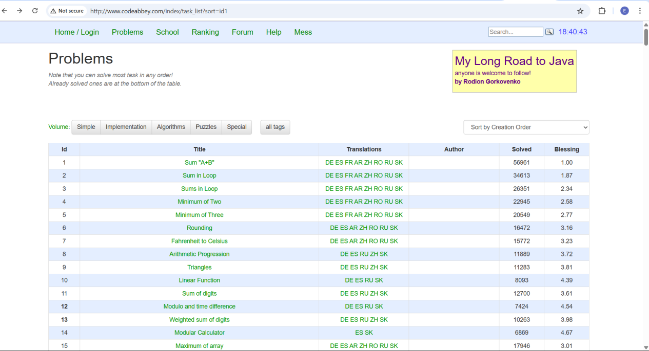

URL -- <http://www.codeabbey.com/index/task_list>

Targeted audience -- People who are learning how to code

Things I like:

* It has a good amount of problems to solve which can help improve coding skills.
* Its free

Things that I do not like:

* The page does not name the Authors of the Problems
* It does not specify the languages we can use for the problems at first glance.
* Some questions are limited to certain languages.
* Some of the features of the website are unnecessary e.g Blessing and Ranking
* The homepage of the website could be more organized
* The graphic design of the page could be improved
* Some of the font sizes need to be more readable and bolder.

Suggestion for improvement--

Website needs better graphic design and more attention to readablity.